# **Elementor Tips**

## Set **Your Layout width** for your theme

Default width is 1140px we will change it to 1170

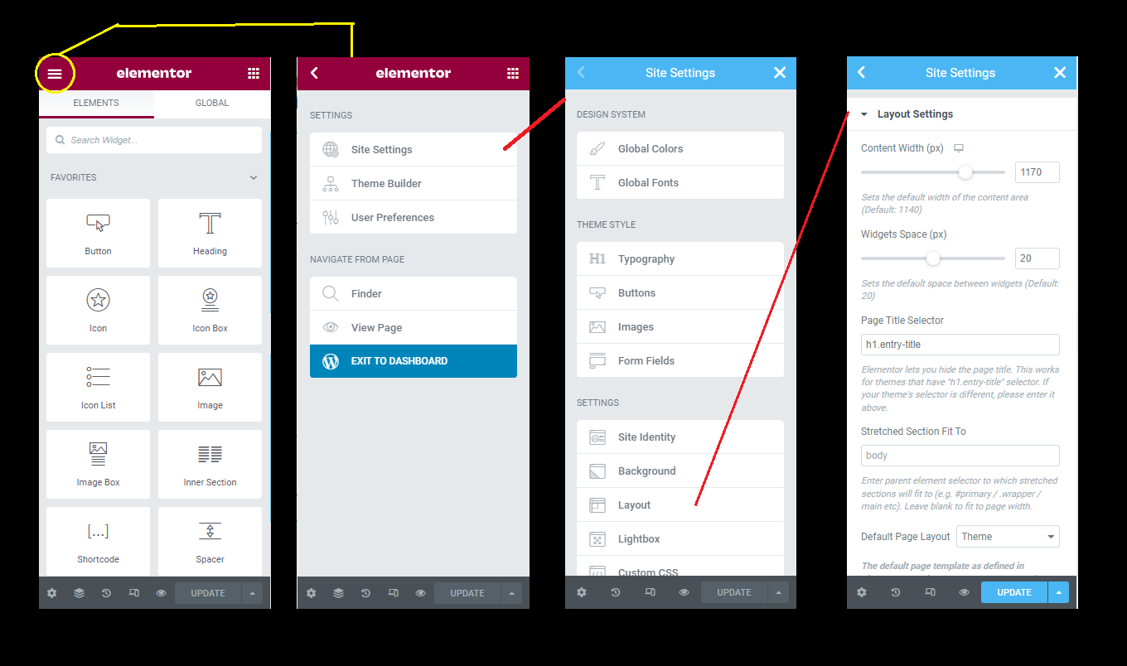

## Set **Global Font Color** for your theme

Go to any elementor page and flow the steps

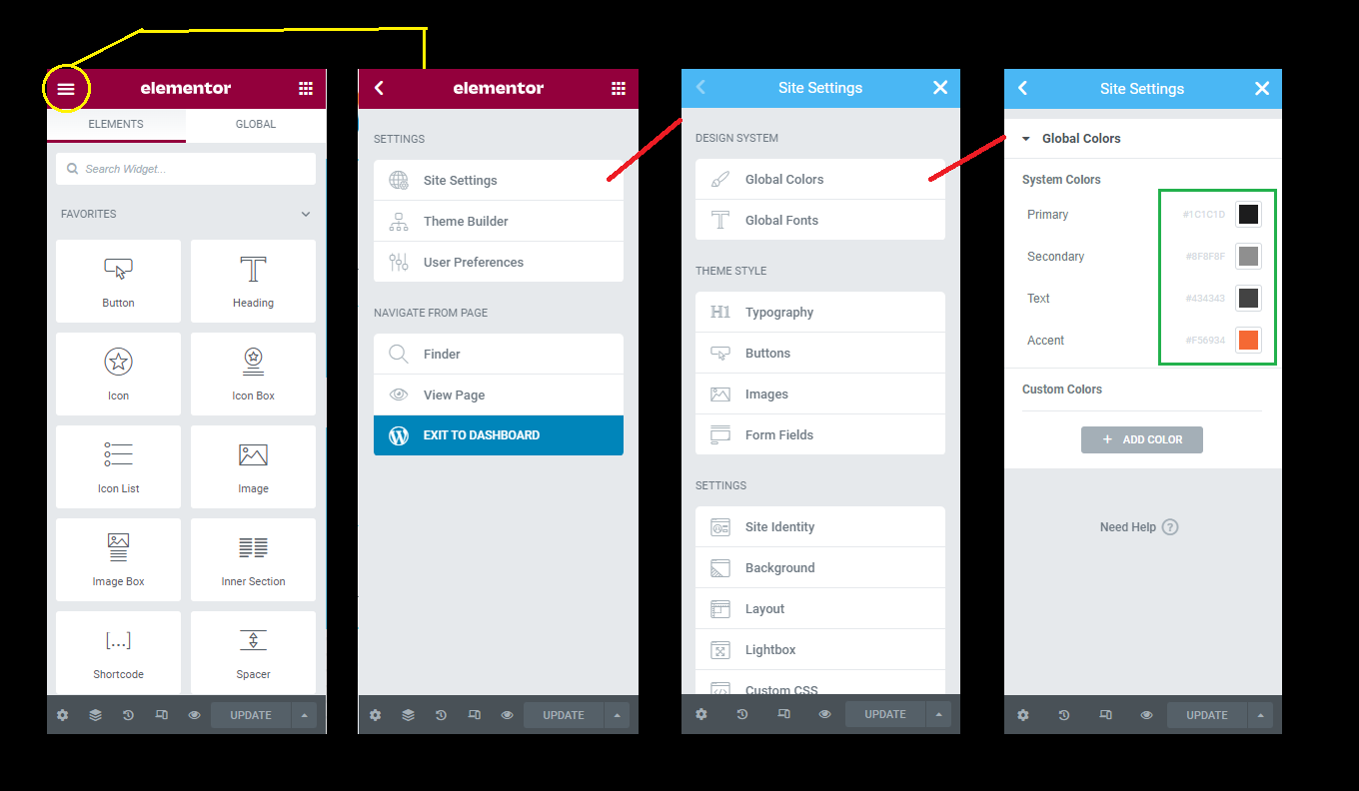

## Set **Global Font Family & Size** for your theme

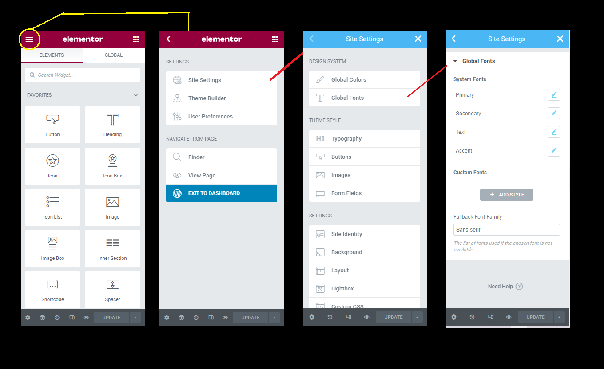

## Set **Website Typography** for your theme

## Elementor >> Settings >> General

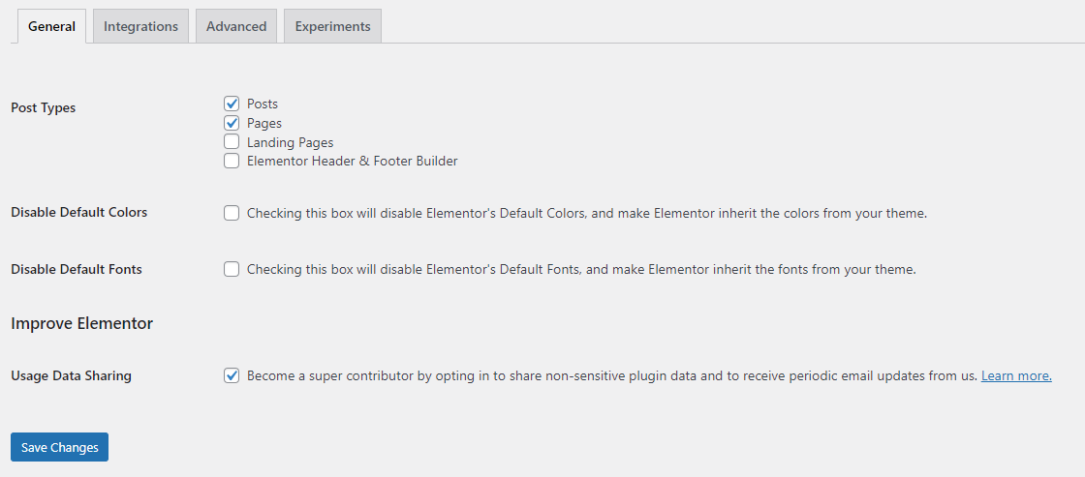

1. Post Type :: Elemntor will only enable in the checked type option
2. Disable Default Colors :: This will disabled elementro default setting and will take from your theme css file
3. Disable Default Fonts :: This will disabled elementor default font family and will take from your theme css file

## Elementor >> Tools >> General

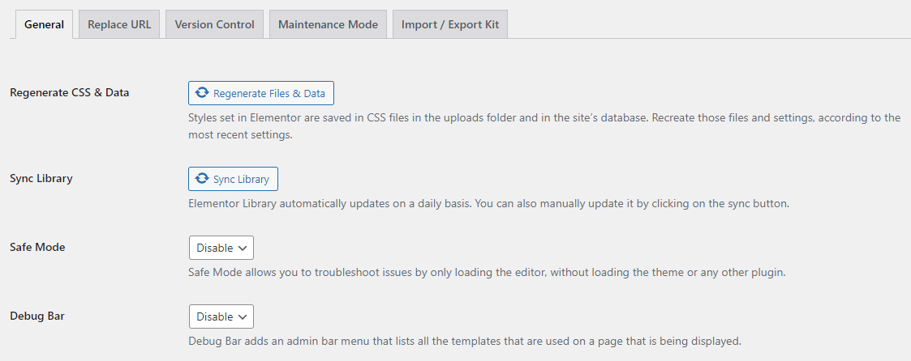

If some time you can see the update in your admin panel but it will not reflect on front-end

You need to click on Regenerate CSS & Data this will update all your elements css and assets with the latest one

Note: Not Recommended the use as some time it will lost your changes this is the last option only

## Elementor >> Tools >> Replace URL

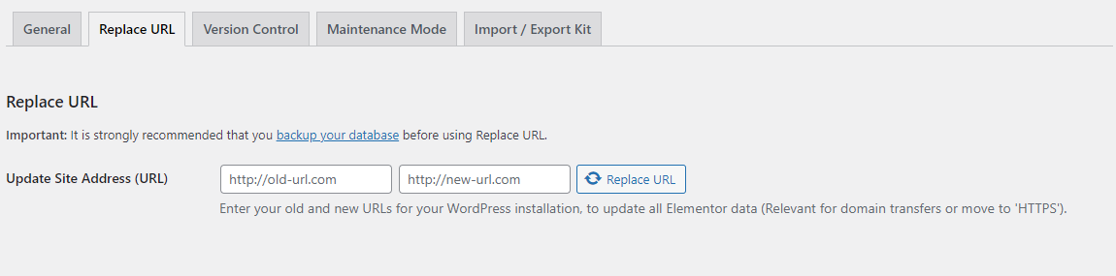

When you migrate your website from one domain to another domain you need to change the URL

**Enter Your >>**

Old Url >> <http://192.168.1.109/gesia>

New Live Url >> <http://www.crossshore.org/projects/gesia>

Hit the Replace URL button it will replace your old URL to the new URL